**Name: SHAMJAD MAZOOD NAZER**

**Roll No: 36**

**Batch: RMCA-B**

**Date: 10-06-2022**

**ADVANCED DATABASE MANAGEMENT SYSTEM LAB**

**Experiment No.: 10**

**Aim**

To familiarize with SQL Trigger Function.

**Questions**

Create a student table with fields id, name, subject1, subject2, subject3 and total, percentage. For each entry of row, update total marks and percentage using triggers in SQL.

**Procedure**

create database TRIG;

use TRIG;

**Output Screenshot**

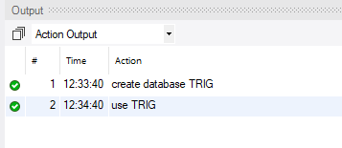

CREATE TABLE Student(

tid int(4) NOT NULL PRIMARY KEY auto_increment,

name varchar(30),

subj1 int(2),

subj2 int(2),

subj3 int(2),

total int(3),

per int(3)

);

**Output Screenshot**



desc Student;

**Output Screenshot**

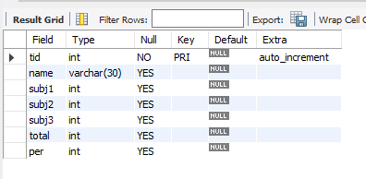

create trigger marks

before

INSERT

on Student

for each row

set new.total = new.subj1 + new.subj2 + new.subj3, new.per = new.total * 60 / 100;

desc Student;

**Output Screenshot**



insert into Student values(36, "JAD", 28, 35, 40, 0, 0);

select * from student;

**Output Screenshot**

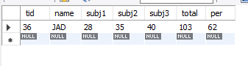

create table marks(mark_id int primary key auto_increment,

name varchar(20),

total_mark int

);

**Output Screenshot**



create trigger mark_trigger

after

INSERT

on Student

for each row

insert into marks(name, total_mark) values (new.name, new.total);

**Output Screenshot**



insert into student (tid, name, subj1, subj2, subj3)values(37, "SHEFANY", 35, 36, 42), (93, "JADSPRIT", 25, 24, 20);

**Output Screenshot**



select * from marks;

**Output Screenshot**

